How to use the Student Mark Analyser Tool

1. **How to compile and run the code:**

* Install Java 8.0 or higher (<https://www.java.com/en/download/>)  
  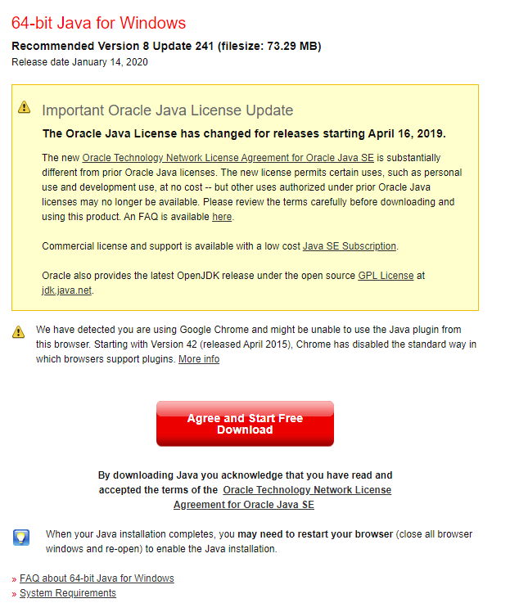
* Download the .Java File   
  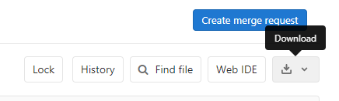
* Download the Excel CSV file containing your students marks
* Navigate to the .Java File directory in CMD using “CD”



* Copy and paste the following line:

“javac StudentMarks.Java”  


* The Program is now running, navigate to the Excel CSV file directory and open it.
* The program should now display a table with the student’s marks.